Wrong Grade Level in COHI

If you accidentally put the wrong grade level when entering Manually Entered Course History you can follow these steps to correct.

Example: Student Fulton Baker’s first manually entered COHI was for the 14/15 school year. H should have been a 9th grader but when added it was marked that he was in 8th grade. You will notice that school year and the grade level are greyed out and cannot be changed on this screen.

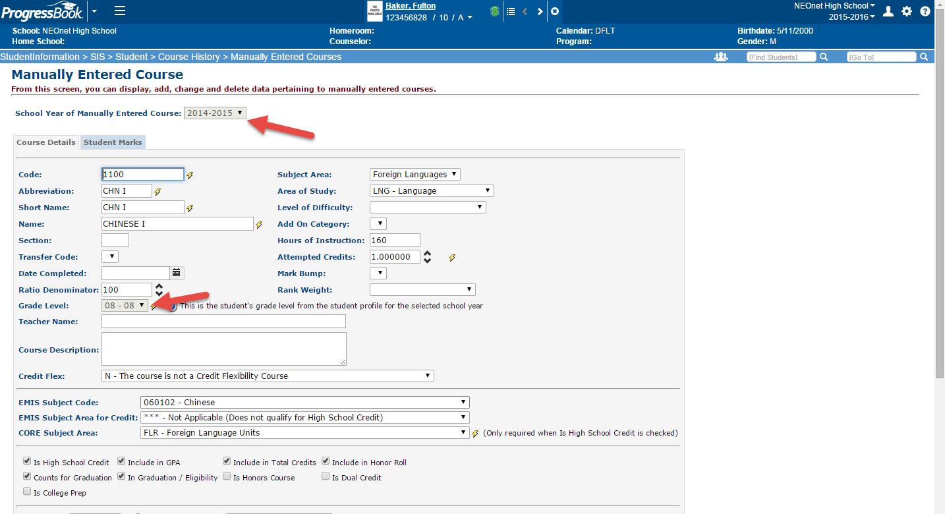

The grade level is driven by the general screen on the profile page. To change, go to the school year that you put in COHI. Example 2014/15 and pull up the student’s profile screen.

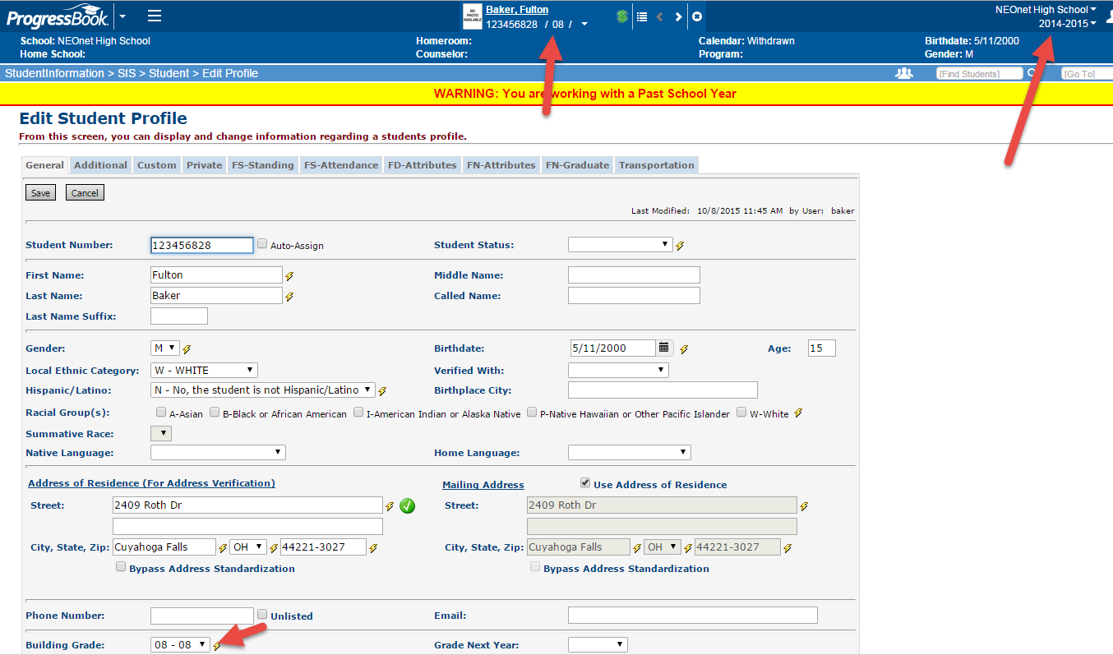

Change the building grade to the correct grade level and add the grade next year. SAVE

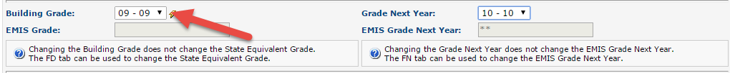

Go back to SIS>Student>Course History and pencil the COHI. It now shows the correct grade level.

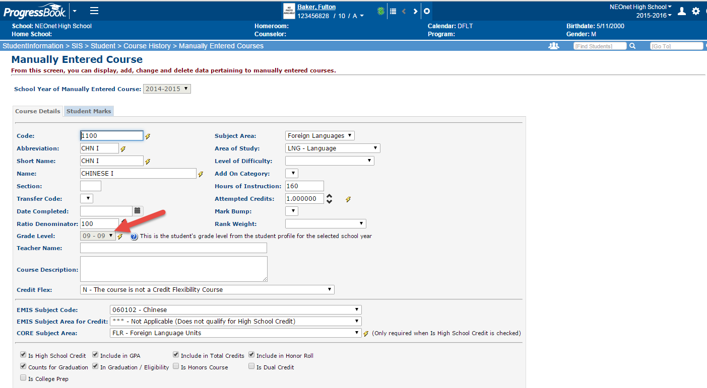

Please note: If you added multiple COHI with the incorrect grade level this will correct ALL COHI for that school year.

If you have any questions or issues please email [studenthelp@neonet.org](mailto:studenthelp@neonet.org)