In the summer 15.0 release the feature was added for districts to now have the option to publish official DASL report cards to Parent Access instead of mailing out hard copies for all students.

If you want parents to view paper report cards online you must first, setup in GradeBook to View Report Cards on ParentAccess:

-Admin Home Page, PA Admin, Page Level Security, View Official Report Cards.   
  
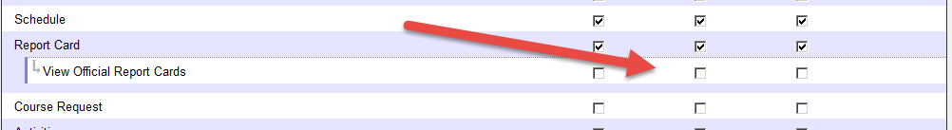

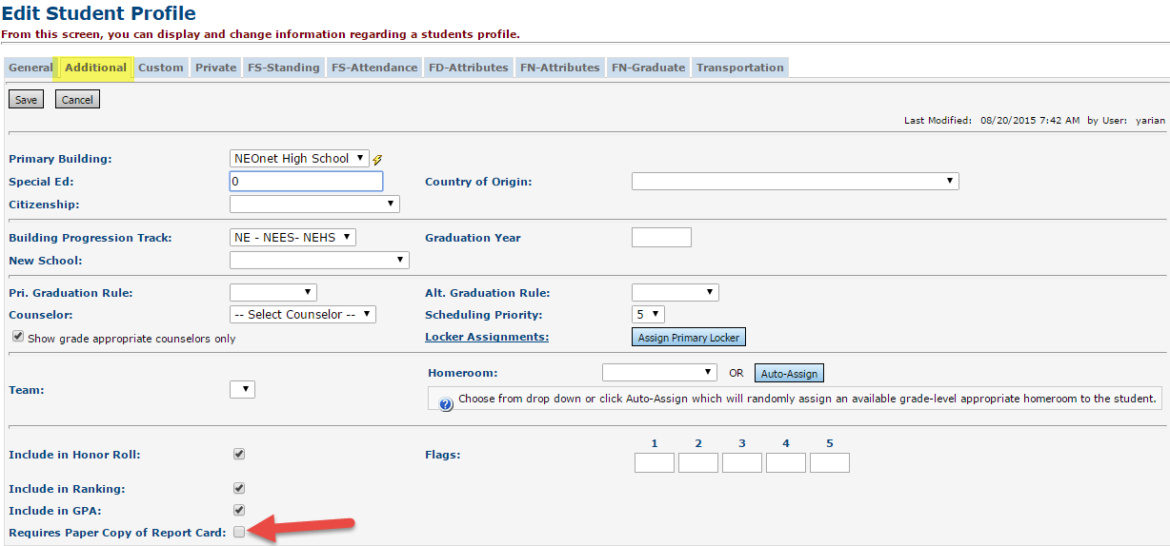In DASL a ‘Requires paper Copy of Report card’ checkbox was added on Additional tab of Profile

Student Profile Bulk Update has the ability to use an Ad-Hoc membership & mass update this field

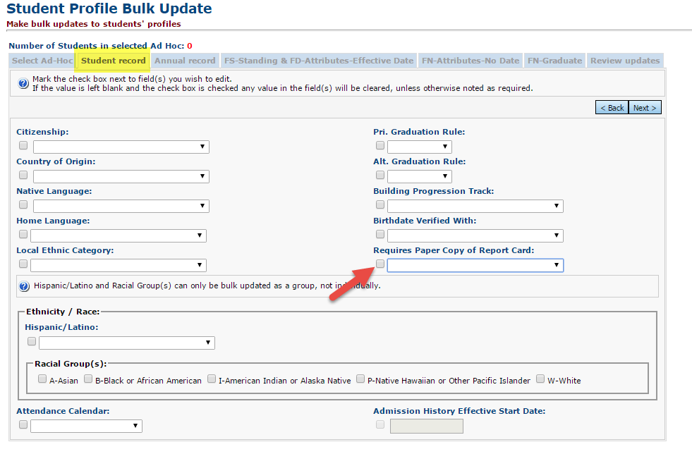

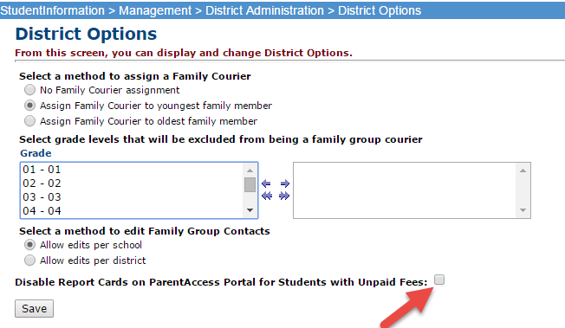District Options (Management>District Administration> District Options) Disable Report Cards on ParentAccess portal for students with unpaid fees.

*\*\*If you select this box parents of students who have outstanding fees do not get the link to View Report Cards at all in ParentAccess*.

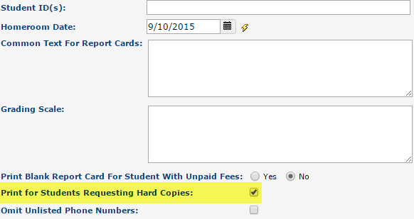New prompt on R700 named ‘Print for students Requesting Hard Copies.’ If checked only students with the additional tab field checked will get a paper copy in your Print Management screen.

Steps in DASL:

1. Run your R700 like usual and preview results in print management screen.

Ensure you keep the ‘Print for Students Requesting Hard Copies’ UNchecked  
(important items to check are marks appearing, comments, attendance, GPA’s, honor roll messages)

1. 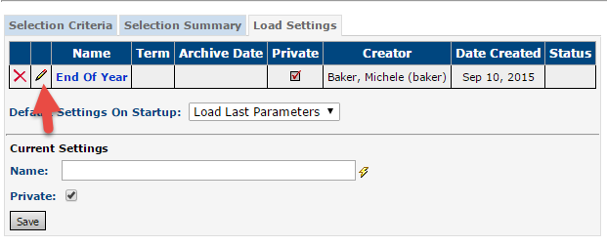If you are satisfied with results, go to **Load Settings** tab and save your load settings. Ensure the name field displays the name of the report as you want it to display on ParentAccess.
2. Next click the **pencil** to edit
3. 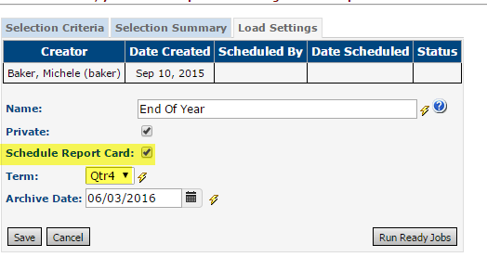Check **Schedule Report Card**
4. Select the **Term**
5. Change **Archive date** if needed.
6. Click **Save**
7. ***Re-pencil*** the Load Settings
8. Click **Run Ready Jobs**
9. The job will be visible on your print management screen once it is kicked off and will include all students that moved to the vault.

Also, a status of Pending will appear next to your Load Settings job. Once the job is finished the status will change to Complete.

_____>Continued

1. We suggest going to GradeBook and verifying you see report cards on a sample student:

**NOTE *This process will strip the students address once placed in ParentAccess due to custody situations.*   
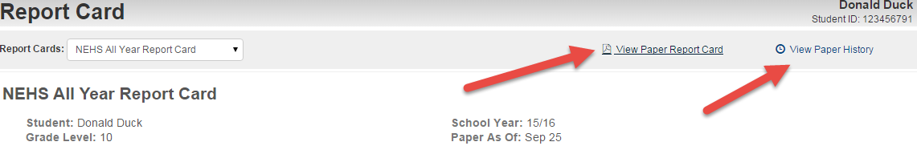

1. Lastly run your R700 again and Ensure you keep the ‘Print for Students Requesting Hard Copies’ checked.  
   The job in your Print Mangement will only include the students needing a printed hard copy.

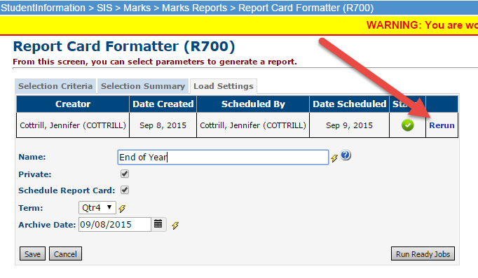

To rerun the report cards due to grade changes/mistakes:

1. **Pencil** Load Settings
2. Click **Rerun**
3. Click **Run Ready Jobs**

**Note the Paper As of Date will change for all students.